Options And Derivatives Programming in C Plus Plus 07/04/2025

AccompanyingTrack List (music) – to work to:

Reflekt x London Grammar – need to feel loved/ hey now (lost version)

We are working from the following book by Carlos Oliveira written in 2016:

© Carlos Oliveira 2016 C. Oliveira, Options and Derivatives Programming in C++, DOI 10.1007/978-1-4842-1814-3_1

for the code samples thus far I have only been able to feed code samples for his book Practical Financial Engineering in C++ here:

https://bitbucket.org/coliv/financialsamples/src/master/FinancialSamples/

his website here is supposed to have the code specifically for the options and derivatives book:

https://coliveira.net

but I cannot find a code repo for the book there.

As the title of this document indicates, we will be building and running C++ applications which often wind up being stored in files with a ‘cpp’ extension. In order to code/create these files we will need an integrated development environment. A popular choice is Visual Studio Express. But having checked the installation requirements I note that 10GB of space is required for an installation of Visual Studio Express with C++ and currently the laptop which I am using does not have that amount of space. Therefore (for the time being) I will resort to a free online integrated development environment, namely:

https://www.onlinegdb.com/online_c++_compiler

This is not the only free online IDE available and in time I may try another such environment.

Modelling Options in C++ (chapter 1 – page 10 numerically/30 on the scroll)

We’re going to create a C++ class which can be used as a base template (a base class) for a programme which can compute the value of any option (a call option or a put option) for any kind of underlying asset (be it a commodity or a stock).
When we create a class in C++ we must ensure that we design the class well such that it can interact properly with the existing community C++ framework and available libraries. Thus whenever we create or design a class we must ensure that it contains 4 functions which we call ‘member functions’ these functions are used in a standard way to create or copy objects from a class and they also ensure that that the class/object behaves in a standard way according to the established C++ community programming paradigm. The four member functions are:

The Four C++ standard member functions of a class:

- The constructor: objects are created on the basis of a class and constructors tell a programme how to initialise (or create) an object, a class can have several constructors which will create or initialize the object in a different way. The constructor then is a special ‘initialising’ function and it has the same name as the class. Constructors can be built to accept parameters (which it will use to create the object with specific properties) or receive no parameters (note that a constructor which is specified to receive no parameters is known as the ‘default constructor’. If you do not code a default constructor into the class, when the C++ compiler, compiles the class it will create one. Usually it is better to specify a constructor and avoid using the default so that you can properly specify variables and variable types (such as double and int) which may be required by the class.
- The copy constructor: This function initializes an object, but rather than initializing it from the class definition (which is what the constructor proper does), it initializes an object from an already existing object. Again, if you do not specify a copy constructor when you define your class the compiler will create one for you which will specify to copy stored values/parameters from the existing object into the new object. But this can cause problems if a stored value is an existent object for example a pointer to a memory slot or an existing object or variable in memory. If you write a copy constructor you can avoid copying over values of a certain kind (such as pointers to memory) as when the compiler creates a default copy constructor very often the created object will not be ‘semantically aware’ of the kind of values or variables that are being copied across.
- The destructor: this function defines what to do with data or values associated with the object when an object is destroyed. Again the compiler will generate a default destructor if you do not specify one, but if you want to handle the destruction of data you would be better off specifying one.
- The assignment operator: When data is copied between objects something called the ‘assignment operation’ is the function which accomplishes the copying of data between objects, this should be defined correctly to ensure that data is copied properly between objects.

We can give an example of an assignment operator function copying the contents of one object to another (current) object (identified with using the keyword ‘this’) as follows:

GenericOption &GenericOption::operator=(const GenericOption &p)
{
if (this != &p)
{
m_type = p.m_type;
m_strike = p.m_strike;
} return *this;
}

Note the indentations as specifying the beginning and the end of the ‘function’ definition construct/section of the code and the ‘if’ construct definition/section of the code – thus C++ is an indented language which uses indentation to separate and identify the logical sections of the code (hence why you’ll need a C++ integrated development environment to correctly indent the code) and notice also the check prior to the copy step within the ‘if’ construct: the code checks that the two GenericOption objects are different (this != &p) before the copy step begins. Note that the keyword ‘this’ refers to the current GenericOption created object and that ‘&p’ refers to a separate additional GenericOption created object. This check will ensure that the copy process only executes if the two objects are different therefore avoiding a potentially expensive and unnecessary copy process triggering when the contents of the two objects are actually the same already, by contents we mean here the parameters m_type and m_strike, and the copying is actually the setting of the two parameters m_type and m_strike, in the current GenericOption created object (referred to by the keyword this) to be the same as the parameter values (p.m_strike, p.m_type) in the other GenericOption created object called p, thus this part of the code sets these parameters.

The GenericOption Class and computing the value of an option at expiration

Our initial example class ‘GenericOption’ will contain the minimum code necessary to calculate the value of options at expiration and it will be constructed in the ideal way stated previously and therefore contain a constructor, a copy regular constructor, a destructor and an assignment operator.
The main constructor will do very little and only be responsible for initializing some provate variables and it is worth noting that giving constructors very few responsibilities (keeping them as simple as possible is good practice, because we want to keep constructors as fast performing as possible and relegate complex operations to member functions that will be called once the object is created – complex constructors will make your code run slower.
Two types of options will be recognized by the GenericOption class, a call option and a put option and we will use an enumeration (array) called OptionType and this will contain the values OptionType_Call and OptionType_Put. Depending on values passed to the constructor at initialization the object will then behave either as a put or as a call option. The constructor also requires the strike value of the option and the cost of the option when it was bought (note that the ‘cost of an option’ is something we’ll look to calculate fo ourselves moving forwards but for now we assume that the option cost is provided to us by the exchange).
Two functions in the class called valueAtExpiration and profitAtExpiration provide the functionality. valueAtExpiration computes the value of the option at the time of expiration, and to perform this calculation it needs the current price of the underlying asset. The value of the option at expiration for a put needs to be strike – price and if the strike is less than the price e.g. 80 – 90, then computation yields a zero (the option cannot be priced less than zero). In the case of a call option the computation to compute the value of an option at expiration is the reverse, so price – strike and in the case where the strike is greater than the price (e.g. 90 – 100) the result again, is zero, for again an option cannot be valued less than zero. Here then is the code for the function valueAtExpiration:

double GenericOption::valueAtExpiration(double underlyingAtExpiration)
{
double value = 0.0;
if (m_type == OptionType_Call)
{
if (m_strike < underlyingAtExpiration)
{
value = underlyingAtExpiration - m_strike;
}
} else // it is an OptionType_Put
{
if (m_strike > underlyingAtExpiration)
{
value = m_strike - underlyingAtExpiration;
}
}
return value;
}

Again, notice the highly indented style of the code, partly to frame/delineate the definition of the function itself and partly to mark off the (nested) if statements/constructs, their beginning and their end.
Notice also that the Option value is defaulted to zero.

The second function in the GenericOption class is the profitAtExpiration function. Having already computed the value of the Option at Expiration we can then go on and subtract the premium which we originally paid for the option from the value which the option is worth now, and in the following function that premium is stored in the static class member variable m_cost, notice also that we default the final profit (stored in the variable finalValue to 0), notice also the call to the function valueAtExpiration :

double GenericOption::profitAtExpiration(double underlyingAtExpiration)
{
double value = 0.0;
double finalValue = valueAtExpiration(underlyingAtExpiration);
if (finalValue > m_cost)
{
value = finalValue - m_cost;
}
return value;
}

The Complete C++ Code listing for the GenericOption Class

We state the full code below for the first C++ implementation of a programme which computes the profit from an Option and that code is comprised of a header (interface) file (GenericOption.h) which describes the structure of the class, and also the main implementation file (GenericOption.cpp) which actually implements the class:

Listing 1-1. Interface/header file for the GenericOption class

//
// GenericOption.h

#ifndef __CppOptions__GenericOption__
#define __CppOptions__GenericOption__

#include <stdio.h>

//
// option types based on direction: call or put
enum OptionType {
OptionType_Call,
OptionType_Put
};

//
// class that represents a generic option
//
class GenericOption {
public:
GenericOption(double strike, OptionType type, double cost); GenericOption(const GenericOption &p);
~GenericOption();
GenericOption &operator=(const GenericOption &p);

double valueAtExpiration(double underlyingAtExpiration);
double profitAtExpiration(double underlyingAtExpiration);
private:
double m_strike;
OptionType m_type;
double m_cost;
};

#endif /* defined(__CppOptions__GenericOption__) */

page 34 of 273 at this point.
Listing 1-2. Implementation of the GenericOption class

//
// GenericOption.cpp

#include "GenericOption.h"

using std::cout;
using std::endl;

GenericOption::GenericOption(double strike, OptionType type, double cost)
: m_strike(strike),
m_type(type),
m_cost(cost)
{

}

GenericOption::GenericOption(const GenericOption &p)
: m_strike(p.m_strike),
m_type(p.m_type),
m_cost(p.m_cost)
{

}

GenericOption::~GenericOption()
{
}

//
// assignment operator
GenericOption &GenericOption::operator=(const GenericOption &p)
{
if (this != &p)
{
m_type = p.m_type;
m_strike = p.m_strike;
m_cost = p.m_cost;
}
return *this;
}

//
// Computes the value of the option at expiration date.
// Value depends on the type of option (CALL or PUT) and strike.
//
double GenericOption::valueAtExpiration(double underlyingAtExpiration)
{
double value = 0.0;

if (m_type == OptionType_Call)
{
if (m_strike < underlyingAtExpiration)
{
value = underlyingAtExpiration - m_strike;
}
}
else // it is an OptionType_Put
{
if (m_strike > underlyingAtExpiration)
{
value = m_strike - underlyingAtExpiration;
}
}
return value;
}

//
// return the profit (value at expiration minus option cost)
//
double GenericOption::profitAtExpiration(double underlyingAtExpiration)
{
double value = 0.0;
double finalValue = valueAtExpiration(underlyingAtExpiration);

if (finalValue > m_cost)
{
value = finalValue - m_cost;
}
return value;
}

int main()
{
GenericOption option(100.0, OptionType_Put, 1.1);
double price1 = 120.0;
double value = option.valueAtExpiration(price1);
cout << " For 100PUT, value at expiration for price "
<< price1
<< " is "
<< value << endl;
double price2 = 85.0;
value = option.valueAtExpiration(85.0);
cout << " For 100PUT, value at expiration for price "
<< price2
<< " is "
<< value << endl;

// test profitAtExpiration
auto limit = 120.0;
for (auto price = 80.0; price <= limit; price += 0.1)
{
value = option.profitAtExpiration(price);
cout << price << ", " << value << endl;
}

return 0;
}

at this point – page 36

Building and testing the GenericOption Class

We need to compile the C++ program in order to get it to work, visual studio with the C++ compiler add on/plug in will do the job but the author has elected to use gcc abd LLVM cc and (using gcc) here are the commands which were issued, the following command, to create a Generic option object:

gcc –o GenericOption.o –c GenericOption.cpp

and this code to create an executable programme from the object (at least I think that is what this line of code is doing – I need to check this):

gcc –o GenericOption GenericOption.o

The above lines of code should create an actual application, which can then be executed just by typing the name of the application which was created previously in the command prompt (within the directory wherein the newly created C++ application/executable now resides):

$ ./GenericOption

and this output should be written out to the screen as a result of that code:

For 100PUT, value at expiration for price 120 is 0
For 100PUT, value at expiration for price 85 is 15

80, 20
80.1, 19.9
80.2, 19.8
80.3, 19.7
80.4, 19.6
80.5, 19.5
80.6, 19.4
80.7, 19.3
...

Further, we can use the generated two dimensional data (which is outputting the two dimensions – price of the underly and profit) to generate a ‘pay-off’ diagram which clearly illustrates when we can expect the option to begin making profit see:

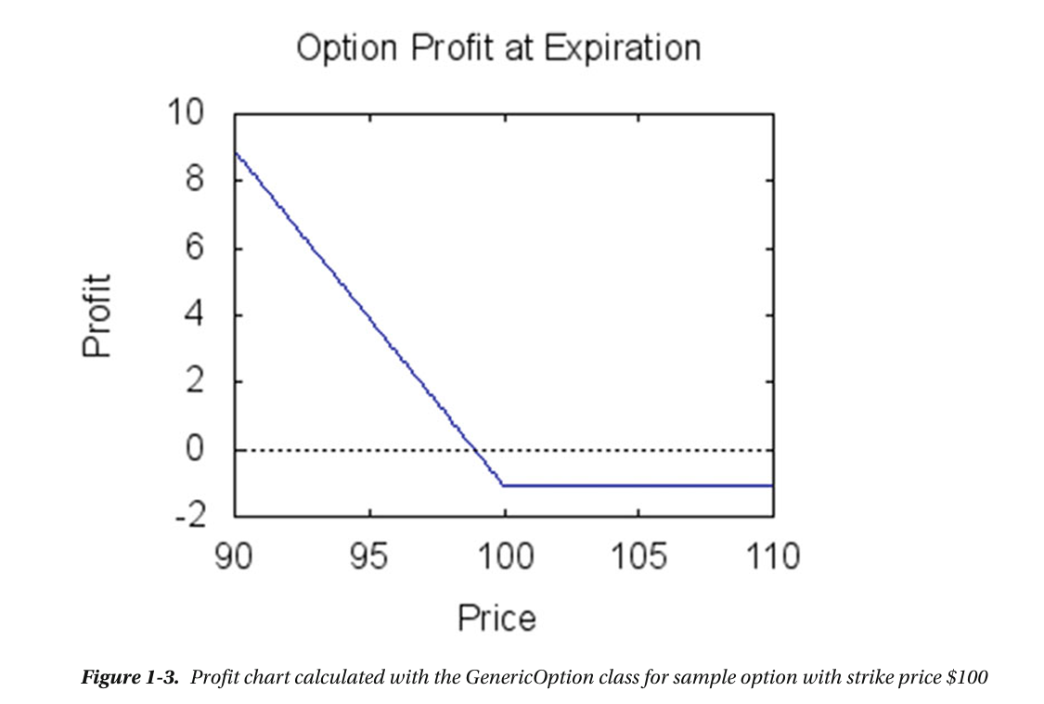

and note that since this is a put whose price is $1 for a strike price of $100 that the put does not begin making profit until the Price of the underlying drops below $99 with the point of change and the characteristic ‘hockey stick’ shape forming precisely at the the ‘strike less option premium’ point on the chart. Note also the helpful red dotted line denoting the threshold below which there is no profit and above which profit increases exponentially with the increase in price of the underlying.

Financial Derivatives (chapter 2 – page 19 numerically/39 on the scroll bar)

In finance a derivative is a term for a contract whose value and properties is based on an underlying asset such as a commodity like gold or stocks in a company such as Apple. Options are a kind of derivative that give the owner the right to buy or sell the underlying asset for a particular price. There are also derivatives which permit the buying and selling of other assets such as corporate credit risk or mortgages (so essentially debt) in other words some derivatives are based on so called ‘illiquid’ assets such as debt.
Over the last few decades finance houses have created a number of derivative contracts collateralizing (collateral is typically something of value used as a guarantee of payment when borrowing money) different kinds of assets such as fixed income instruments (e.g. government/corporate bonds), mortgage backed securities (essentially another kind of bond), risk of defaults (essentially insurance on debt – buying or selling insurance on debt, which is one way of shorting bad debt – see Michael Burry ‘the big short’ and his collateralized debt obligations/CDOs ).
Pricing and trading these derivative contracts is a large part of the work performed by finance houses and quantitative programmers throughout the world.
In this chapter, we take a look at some general characteristics of derivatives and we present a few C++ techniques which are useful for modeling some features of these financial instruments. We explore the following:

- models for derivative pricing: basic ideas used to price derivatives with a few examples
- Credit default swaps – one specific kind of derivative where investors want to buy protection/insurance against defaulting on a debt
- Intererest rate derivatives – where the underlying asset as an interest rate paid at pre-defined periods
- FX derivatives: some exotic derivative contracts
- we're going to look at a Monte Carlo Model for pricing derivatives
- we're going to use STL for derivative pricing and create fast containers with objects for procing derivatives and by this process speed up processing and not incur runtime inefficiencies

Models for derovative Pricing (chapter 2 – page 20 numerically/40 on the scroll bar)

Thus far we have looked at Put and Call options. But there are more complex derivatives such as Credit Default Swaps. Credit Default Swaps require a payment when an entity is in default – this these derivatives are based on debt and defaulting on debt. Another derivative based on debt is a collateralized debt obligation which requires payments based on a risk score/level of borrowers.
All derivatives traded in the market can be analysed used a random walk model dicoered and applied by American economists in the 20th century, the model was developed and popularised by Robert Merton who generalised the Nobel prize winning Black Scholes Merton model for options pricing. The model (crudely speaking) assumes that the price of an option moves randomly through time, but that the 'frequency of different measures of random movement' follow a standardised normal distribution (with a mean of zero and the standard deviation being the time adjusted annualised standard deviation of movement in price for whatever the underlying security is). Granted this is only an approximation of market behaviour but it is so close to how the market place actually behaves that models based on random walks tend to be very successful. Thus the models are used to accurately determine prices for derivatives including options and much of this book centres on exploring this pricing model to create software to analyse, price and trade derivatives.

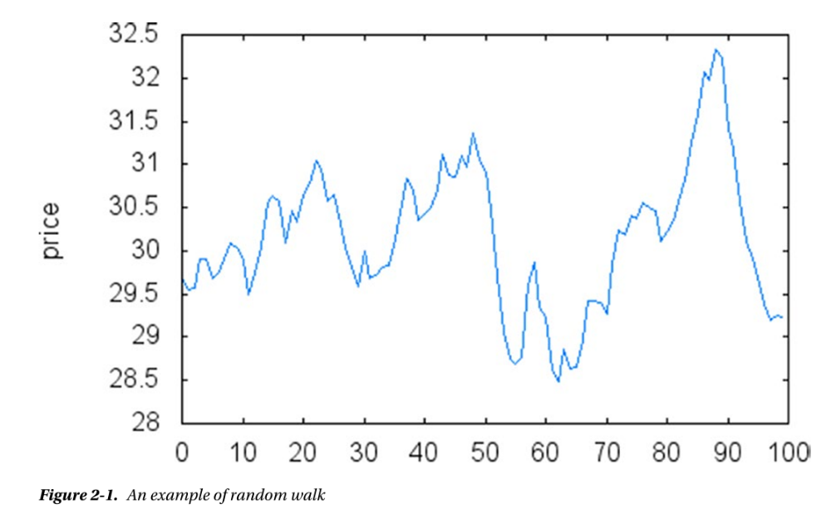

Credit Default Swaps (chapter 2 – page 20 numerically/40 on the scroll bar)

Risks of insolvency (business going bankrupt) can be offset using Credit default swaps which essentially take their value from the difference between the value of the business and that business's liabilities. Thus in the event that a business goes bankrupt, this is a kind of insurance policy. (note there seems to me something questionable about effectively creating opportunities for investment on bankruptcy itself....)

Collateralised Debt Obligations (CDOs) (chapter 2 – page 22 numerically/42 on the scroll bar)

The payments from various loans can be bundled up/or packaged up together into something called a CDO (collateralized debt obligation), and those CDOs can be comprised of good loans and bad loans. The good loans are triple A rated (AAA) and the bad loans are called 'subprime', subprime because it is more likely that the person who took out the loan will default (not keep up with the payments/go bankrupt). Given that mortgages are loans then, CDOs can be created based on a bundle of mortgages, and those mortgages can be AAA and/or subprime. Just prior to the crash of 2008 a very large number of subprime mortgages (bad debt essentially) were being packaged up into CDOs (securitised) and sold see:

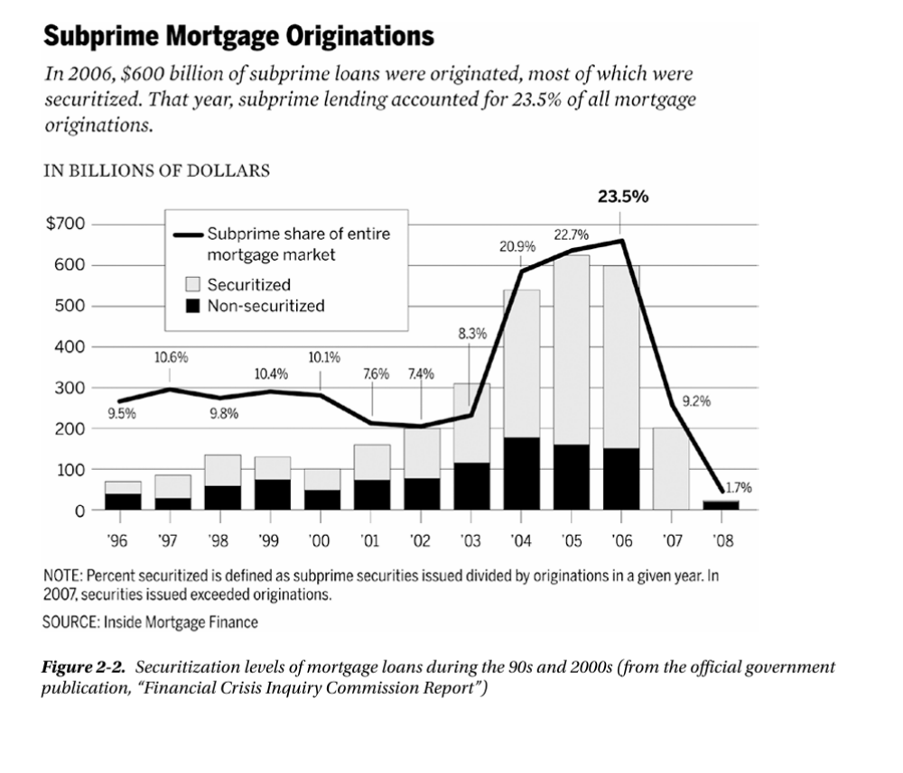
You can see that from around 2003 the number of securities (bonds/CDOs) comprised of subprime mortgages (bad debt essentially) shot up – essentially selling bad dept to investors; and this is because the credit agencies were vetting the bonds/CDOs full of bad mortgages, AAA. Read that last sentence again. The credit agencies meant to vet the rating of the CDOs/mortgages properly were badging the worst kind of debt as the best kind of debt, and thus investors were buying billions worth of bonds/CDOs thinking they were a sound investment – the best investment in fact when in fact they were buying essentially rubbish. As the beginning of (possibly the best contemporary film out there that there is) The Big Short states, Dr Michael Burry (a former medical doctor turned Hedge Fund owner) did what nobody else thought to do: he looked. He looked at what these AAA large mortgage backed securities were comprised of and found that they were in fact largely made up of mortgages against people with bad credit and that (therefore) as soon as interest rates were hiked, the bonds would fail. So what did he do? He bought Credit Default Swaps (see above) which are essentially insurance against risk/liability for debt i.e. when the mortgage-backed-bond becomes worthless owing to the constituent mortgage owners defaulting/going bankrupt the insurance company has to pay out, effectively shorting the housing market (or more accurately the mortgages for the houses in the housing market where the mortgages are the debt assets being traded with the houses being collateral), hence: ‘the big short’. He made almost $1 billion from that short position for the investors in his hedge fund – Scion Asset Management.
If you don’t find the fact of CDOs/bonds comprised of subprime mortgages being sold as triple A (AAA) mortgages scandalous, you either don’t understand or you’re not paying close enough attention.

FX Derivatives (chapter 2 – page 23 numerically/43 on the scroll bar)

The value of these contracts is derived from the variance between currencies. Not only are these contracts subject to speculation but they are also used as hedging devices for offsetting risks in foreign investments. Most global companies that buy or sell products in a foreign market use FX derivatives to avoid the impact/unpredictability of currency fluctuations. Since near real time is needed for fx traders and C++ is one of the fastest (if not the fastest) languages for this purpose, C++ has become the language of choice to handle FX derivative prices.

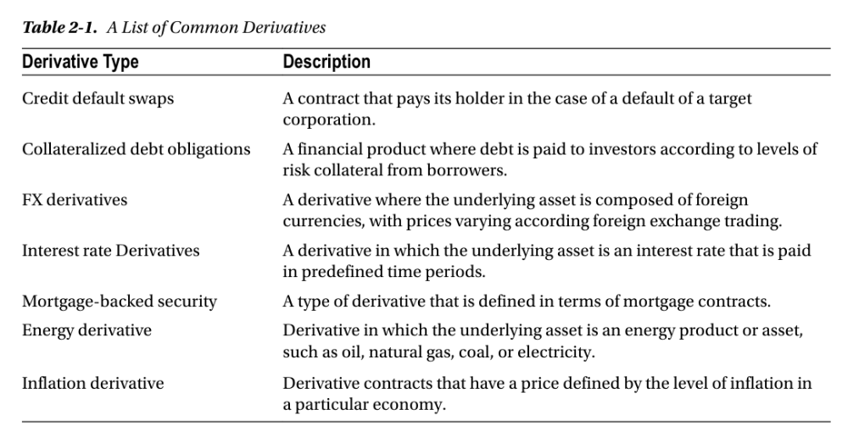

Generating a random walk (chapter 2 – page 27 numerically/47 on the scroll bar)

One key point to note in the next section is that the C++ Rand() function returns a random integer in the range between 0 and rand_max 32767. Thus the line of code in the 'computeRandomStep' function in the RandomWalkGenerator class listing below which takes the modulus (remainder) of the random number returned by rand() when divided by the number 3 can be simulated 3 times below to check for the result of that computation.

Given the code:

const int num_directions = 3;
int r = rand() % num_directions;

and given that rand() in C++ is a random integer between 0 and 32767 let us simulate 3 results from this piece of code:

int r = 32111 % 3 = 2
int r = 27665 % 3 = 2
int r = 12444 % 3 = 0

We see that the above section of code produces the results 0 and 2 and yet the remainder of the code (with the subsequent conditional if statement) below only accounts for 2 options (the modulus being 1 or 0, but clearly there is a third option: namely that the modulus can be a value other than 1 or 0 – in the above case 2). That third option is not explicitly handled but the implicit directive is: 'do nothing' i.e. no price change. Thus the code below explicitly handles 2 cases or logical outcomes (0 and 1) and implicitly handles a 3rd case or logical outcome (in this case very likely 2) by doing nothing:

double RandomWalkGenerator::computeRandomStep(double currentPrice)
{
const int num_directions = 3;
int r = rand() % num_directions;
double val = currentPrice;
if (r == 0)
{
val += (m_stepSize * val);
}
else if (r == 1)
{
val -= (m_stepSize * val);
}
return val;
}

The complete listing (with code description) of the C++ random walk generator class (chapter 2 – page 29 numerically/49 on the scroll bar)

Listing 2-1. Interface/header file for the RandomWalkGenerator class

//
// RandomWalkGenerator.h
//
// Interface for random walk generator class.
// #ifndef and #define are preprocessor directives that prevent the same header file from
// being included multiple times in a single compilation unit.
// this will avoid errors caused by redefining variables, functions, clases etc if header file
// is included more than once.
#ifndef __CppOptions__RandomWalkGenerator__
#define __CppOptions__RandomWalkGenerator__
// the class uses a vector to hold the elements
// of the random walk, so they can be later plotted.
#include <vector>
//
// Simple random walk generating class. This class can be
// used for price simulation purposes.
//
class RandomWalkGenerator {
public:
//
// class constructors
RandomWalkGenerator(int size, double start, double step);
RandomWalkGenerator(const RandomWalkGenerator &p);
// destructor
~RandomWalkGenerator();
// assignment operator
RandomWalkGenerator &operator=(const RandomWalkGenerator &p);
// main method that returns a vector with values of the random walk
std::vector<double> generateWalk();
// returns a single step of the random walk
double computeRandomStep(double currentPrice);
private:
int m_numSteps;
// the number of steps
double m_stepSize; // size of each step (in percentage points)
double m_initialPrice;
// starting price
};
#endif /* defined(__CppOptions__RandomWalkGenerator__) */

Listing 2-2. Implementation of the RandomWalkGenerator class

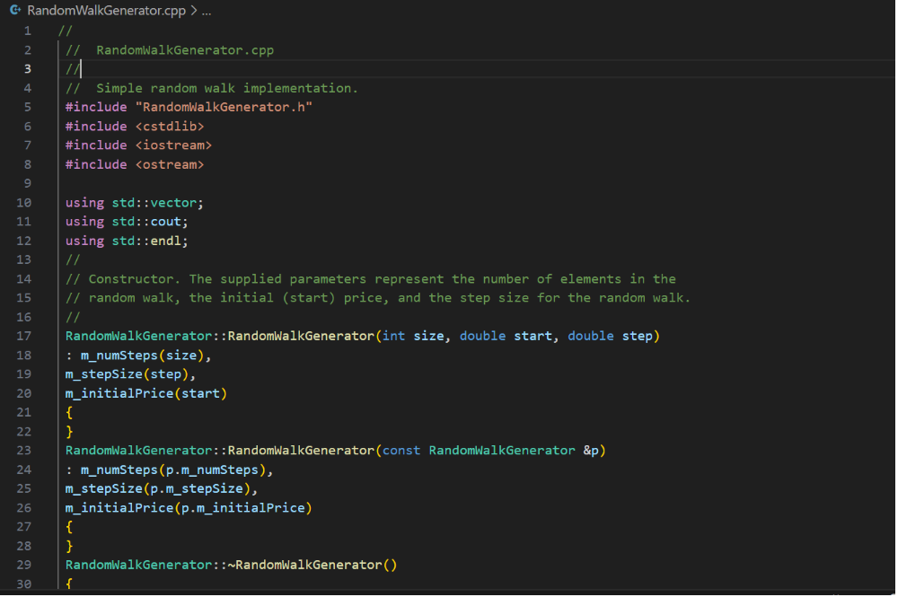

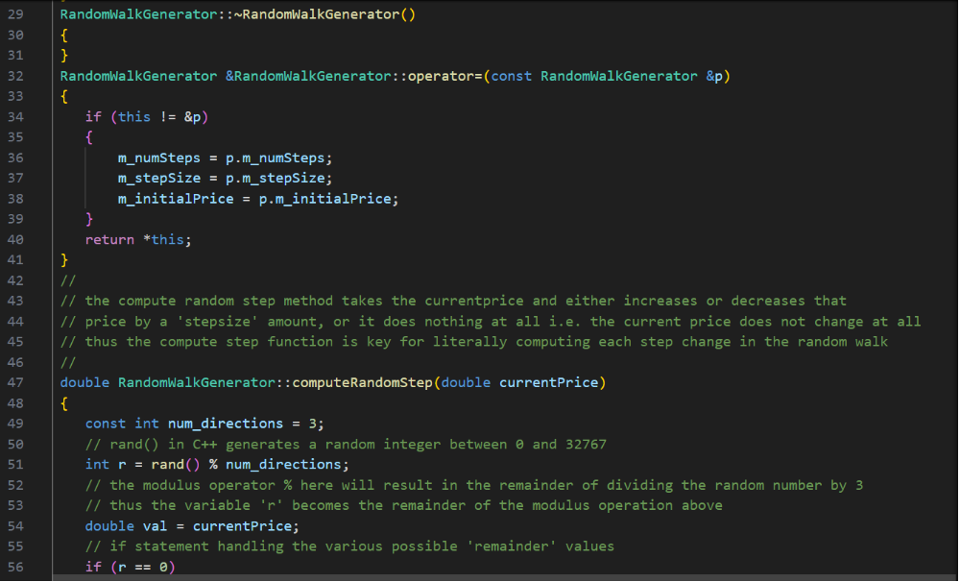

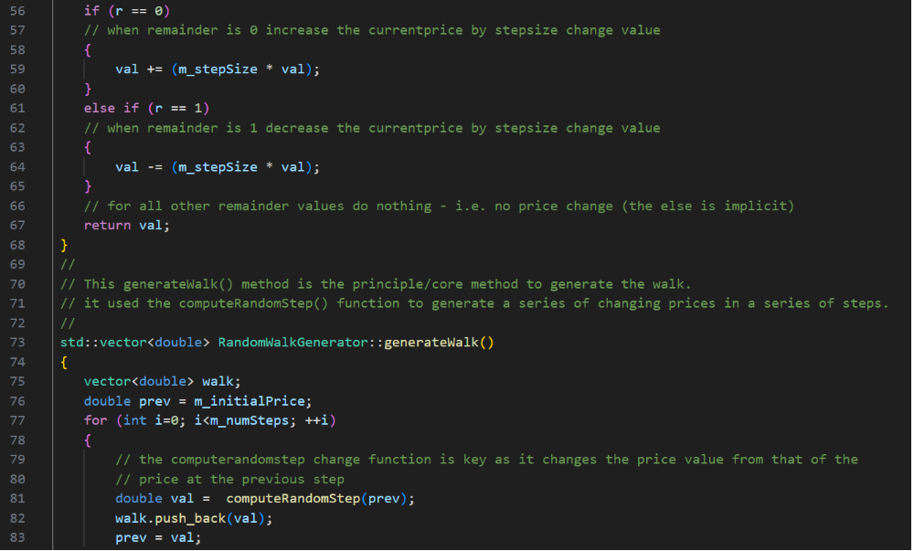
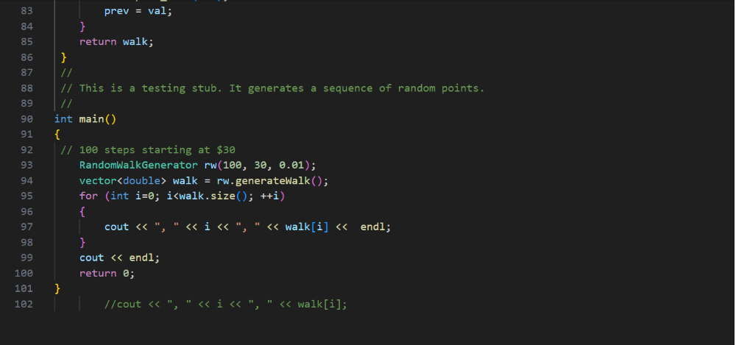
Running this program in Visual Studio code create an exe file and opening the command prompt and running that program executable randomwalk generator executes 100 times from a starting price of 30 using a change factor of 0.01 (1%) either increasing, decreasing or not changing the price at each iteration:

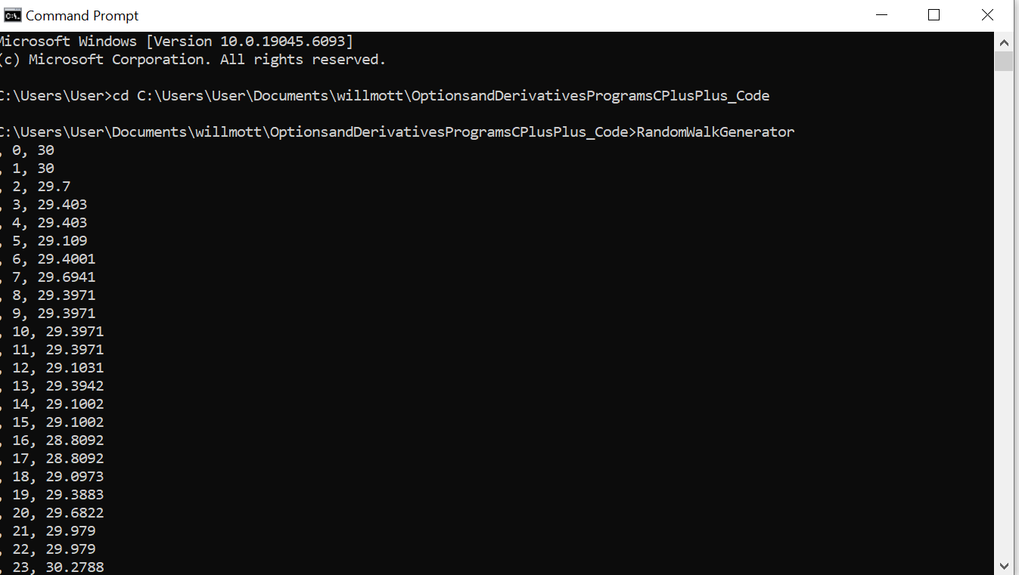

So from line 1 to line 3 we can see the price drops from 30 to 29.7 which is a 1% decrease i.e. 0.3.
Thus we have implemented a random walk in C++.

Taking the random walk script we could easily put the output of the script into a visualisation:

